Ideation Phase
Brainstorm & Idea Prioritization Template

Date | 15 July 2026
Team ID
Project Name | Darshan Ease
Maximum Marks | 4 Marks

Brainstorm & Idea Prioritization Template:
Brainstorming encourages open collaboration and creative thinking to solve problems effectively. For DarshanEase, the team focused on improving the temple darshan booking experience by replacing manual queues with a secure, online platform.
Reference: https://my-mern-project-2-l413.onrender.com/

Step 1: Team Gathering, Collaboration & Problem Statement
- Problem Statement: Traditional temple darshan booking is manual, time-consuming, and error-prone. Devotees face long queues, organizers struggle with slot management, and administrators lack transparency.
- Objective: Build a secure, user-friendly online system using the MERN stack to simplify booking, slot management, and reporting.

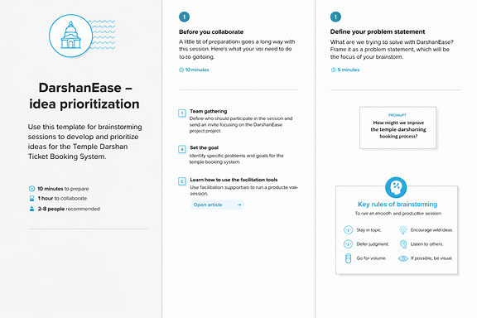

Step-2: DarshanEase, Idea Listing and Grouping

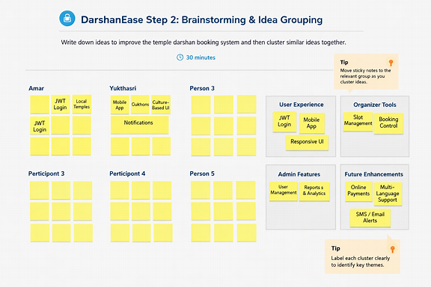

Step-3: Idea Prioritization

